|| Om Shri Sai ||

B-Trees

Introduction
A B-tree is a specialized multiway tree designed especially for use on disk. In a B-tree each node may contain a large number of keys. The number of subtrees of each node, then, may also be large. A B-tree is designed to branch out in this large number of directions and to contain a lot of keys in each node so that the height of the tree is relatively small. This means that only a small number of nodes must be read from disk to retrieve an item. The goal is to get fast access to the data, and with disk drives this means reading a very small number of records. Note that a large node size (with lots of keys in the node) also fits with the fact that with a disk drive one can usually read a fair amount of data at once.

Definitions
A multiway tree of order m is an ordered tree where each node has at most m children. For each node, if k is the actual number of children in the node, then k - 1 is the number of keys in the node. If the keys and subtrees are arranged in the fashion of a search tree, then this is called a multiway search tree of order m. For example, the following is a multiway search tree of order 4. Note that the first row in each node shows the keys, while the second row shows the pointers to the child nodes. Of course, in any useful application there would be a record of data associated with each key, so that the first row in each node might be an array of records where each record contains a key and its associated data. Another approach would be to have the first row of each node contain an array of records where each record contains a key and a record number for the associated data record, which is found in another file. This last method is often used when the data records are large. The example software will use the first method.
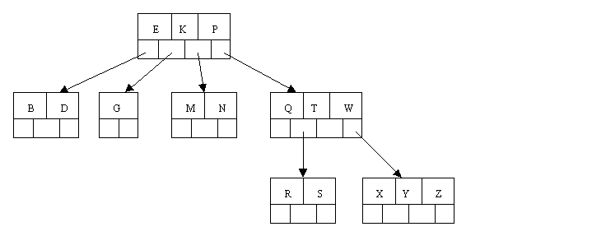
What does it mean to say that the keys and subtrees are "arranged in the fashion of a search tree"? Suppose that we define our nodes as follows:
typedef struct
{
int Count; // number of keys stored in the current node
ItemType Key[3]; // array to hold the 3 keys
long Branch[4]; // array of fake pointers (record numbers)
} NodeType;
Then a multiway search tree of order 4 has to fulfill the following conditions related to the ordering of the keys:
- The keys in each node are in ascending order.
- At every given node (call it Node) the following is true:
  - The subtree starting at record Node.Branch[0] has only keys that are less than Node.Key[0].
  - The subtree starting at record Node.Branch[1] has only keys that are greater than Node.Key[0] and at the same time less than Node.Key[1].
  - The subtree starting at record Node.Branch[2] has only keys that are greater than Node.Key[1] and at the same time less than Node.Key[2].
  - The subtree starting at record Node.Branch[3] has only keys that are greater than Node.Key[2].
- Note that if less than the full number of keys are in the Node, these 4 conditions are truncated so that they speak of the appropriate number of keys and branches.
This generalizes in the obvious way to multiway search trees with other orders.
A B-tree of order m is a multiway search tree of order m such that:
- All leaves are on the bottom level.
- All internal nodes (except perhaps the root node) have at least ceil(m / 2) (nonempty) children.
- The root node can have as few as 2 children if it is an internal node, and can obviously have no children if the root node is a leaf (that is, the whole tree consists only of the root node).
- Each leaf node (other than the root node if it is a leaf) must contain at least ceil(m / 2) - 1 keys.
Note that ceil(x) is the so-called ceiling function. It's value is the smallest integer that is greater than or equal to x. Thus ceil(3) = 3, ceil(3.35) = 4, ceil(1.98) = 2, ceil(5.01) = 6, ceil(7) = 7, etc.
A B-tree is a fairly well-balanced tree by virtue of the fact that all leaf nodes must be at the bottom. Condition (2) tries to keep the tree fairly bushy by insisting that each node have at least half the maximum number of children. This causes the tree to "fan out" so that the path from root to leaf is very short even in a tree that contains a lot of data.

Example B-Tree
The following is an example of a B-tree of order 5. This means that (other that the root node) all internal nodes have at least ceil(5 / 2) = ceil(2.5) = 3 children (and hence at least 2 keys). Of course, the maximum number of children that a node can have is 5 (so that 4 is the maximum number of keys). According to condition 4, each leaf node must contain at least 2 keys. In practice B-trees usually have orders a lot bigger than 5.
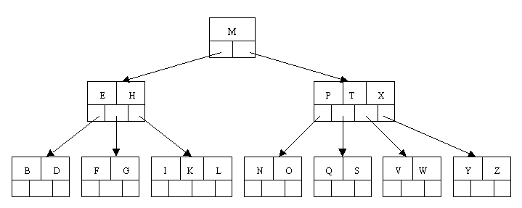
In computer science, a B+ tree (BplusTree) is a type of tree which represents sorted data in a way that allows for efficient insertion, retrieval and removal of records, each of which is identified by a key. It is a dynamic, multilevel index, with maximum and minimum bounds on the number of keys in each index segment (usually called a "block" or "node"). In a B+ tree, in contrast to a B-tree, all records are stored at the leaf level of the tree; only keys are stored in interior nodes.
The primary value of a B+ tree is in storing data for efficient retrieval in a block-oriented storage context — in particular, filesystems. This is primarily because unlike binary search trees, B+ trees have very high fanout (typically on the order of 100 or more), which reduces the number of I/O operations required to find an element in the tree.
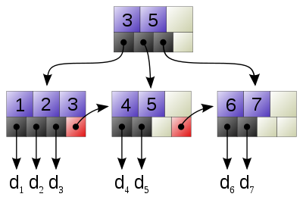
A simple B+ tree example linking the keys 1–7 to data values d₁-d₇. Note the linked list (red) allowing rapid in-order traversal.

